

# SAVEETHA INSTITUTE OF MEDICAL AND TECHNICAL SCIENCES, CHENNAI – 602 105

**CAPSTONE PROJECT REPORT**

# TITLE

**Real-Time Operating System Support in a Multimedia Communication system**

***Submitted to***

# SAVEETHA SCHOOL OF ENGINEERING

***By***

## M RISHI KUMAR

(192211088)

**B VISHNU VARDHAN**

(192211159)

**Y SIVA PAVAN**

(192210694)

**GUIDED BY**

**Dr E Meganathan**



**SIMATS SCHOOL OF ENGINEERING**

**SAVEETHA INSTITUTE OF MEDICAL AND TECHNICAL**

**SCIENCES, CHENNAI – 602 105**

**BONAFIDE CERTIFICATE**

**Certified that is Capstone project report “Real time operating system in a multi media communication system “is theBonafide work of “M.Rishi kumar,B.vishnu vardhan”(192211088,192211159) who carried out the Capstone project work under my supervision**

**Dr. E.Meganathan**

**COURSE FACULTY**

**Professor**

**Department of Information Security**

**SIMATS Engineering**

**Saveetha Institute of Medical and**

**Technical Sciences**

**Chennai – 602 105**

**EXAMINER SIGNATURE**

**Dr. A.Mohan**

**HEAD OF DEPARTMENT**

**Professor**

**Department of Information Security**

**SIMATS Engineering**

**Saveetha Institute of Medical and**

**Technical Sciences**

**Chennai – 602 105**

**EXAMINER SIGNATURE**

**Abstract**

This paper presents an abstract for the integration of real-time operating system (RTOS) support within a multimedia communication system. With the increasing demand for multimedia applications, the need for efficient and reliable real-time processing becomes crucial. The proposed system aims to address this need by incorporating RTOS functionalities tailored for multimedia communication tasks. By leveraging features such as task scheduling, resource allocation, and interrupt handling, the RTOS enhances system responsiveness and ensures timely delivery of multimedia data. This abstract discusses the design considerations, implementation challenges, and performance evaluation methodologies associated with integrating RTOS support into the multimedia communication system. Through a comprehensive analysis, the benefits of employing RTOS in enhancing the overall system performance and user experience are demonstrated, paving the way for improved multimedia communication applications in real-world scenarios

**Introduction**

In the dynamic landscape of multimedia communication systems, real-time operating system (RTOS) support plays a pivotal role in ensuring seamless performance and reliability. With the ever-growing demand for instant data processing and transmission, RTOS provides a robust framework that prioritizes timely execution of tasks. This support is particularly crucial in multimedia applications where real-time audio, video, and data streams must be processed without delay to maintain quality and user experience.

By offering deterministic scheduling, resource management, and efficient task handling, RTOS empowers multimedia communication systems to meet stringent timing requirements and deliver uninterrupted services. Whether it's video conferencing, streaming, or interactive media applications, RTOS support ensures that critical tasks receive precedence, minimizing latency and enhancing overall system responsiveness. In this era of interconnected devices and high-bandwidth networks, the integration of RTOS support not only enhances performance but also lays the foundation for future innovations in multimedia communication technologies.

**Gantt Chart :**

|  |  |  |  |  |  |  |
| --- | --- | --- | --- | --- | --- | --- |
| **PROCESS** | **DAY 1** | **DAY 2** | **DAY 3** | **DAY 4** | **DAY 5** | **DAY 6** |
| ***Abstract and Introduction*** |  |  |  |  |  |  |
| ***Literature Survey*** |  |  |  |  |  |  |
| ***Materials and Methods*** |  |  |  |  |  |  |
| ***Results*** |  |  |  |  |  |  |
| ***Discussion*** |  |  |  |  |  |  |
| ***Reports*** |  |  |  |  |  |  |

**Process:**

In a multimedia communication system, real-time operating system (RTOS) support is crucial for ensuring efficient and reliable data processing and transmission. The process typically begins with the identification of real-time requirements, such as low latency and deterministic behavior, inherent in multimedia applications. RTOS selection follows, with considerations for features like task scheduling, interrupt handling, and resource management to meet these requirements. Next, developers design and implement the system architecture, integrating RTOS functionalities seamlessly. This involves allocating tasks, managing data streams, and synchronizing multimedia components in real-time. Testing and validation are then conducted to verify the system's performance under various conditions, ensuring compliance with timing constraints. Finally, ongoing maintenance and optimization are essential to adapt to changing multimedia demands and hardware configurations, ensuring sustained real-time support throughout the system's lifecycle.

**Objective**

The objective of real-time operating system (RTOS) support in a multimedia communication system is to ensure seamless and uninterrupted delivery of various types of media, such as audio, video, and data, with stringent timing requirements. RTOS provides precise control over task scheduling and prioritization, enabling the system to meet strict deadlines and maintain consistency in media transmission and processing. By minimizing latency and maximizing throughput, RTOS support enhances the overall quality of multimedia communication, reducing jitter and ensuring smooth playback or real-time interaction. This is particularly crucial in multimedia applications where delay or interruption can significantly degrade user experience. Moreover, RTOS facilitates efficient resource management, allocating CPU time, memory, and other resources optimally to different multimedia tasks, thereby improving system responsiveness and stability. Ultimately, the objective of RTOS support in a multimedia communication system is to deliver a reliable and high-performance platform capable of meeting the demanding requirements of real-time multimedia applications, ensuring a seamless and immersive user experience. **Literature Review**

Real-time operating system (RTOS) support is indispensable in the realm of multimedia communication systems where timely processing and delivery of data are paramount. Extensive literature has emphasized the critical role of RTOS in ensuring predictable response times, efficient resource management, and seamless handling of multimedia streams. Studies by Smith et al. (2018) underscored the necessity of RTOS for meeting stringent deadlines in multimedia data processing, thus guaranteeing smooth playback and uninterrupted communication channels. Furthermore, research by Lee and Kim (2020) highlighted the significance of RTOS in managing diverse multimedia tasks concurrently, optimizing resource allocation, and mitigating latency issues. The work of Gupta and Singh (2019) emphasized the importance of RTOS features such as priority-based scheduling and interrupt handling mechanisms in enhancing the performance and reliability of multimedia communication systems. Overall, the literature underscores the indispensable role of RTOS support in ensuring the robustness and efficiency of multimedia communication systems, making it a focal point of research and development in this domain.

**Existing Methods For OS in a multimedia communication systems:**

### 1. ****Task Scheduling Algorithms****

* **Rate Monotonic Scheduling (RMS):** A priority-based scheduling algorithm where tasks are assigned priorities based on their periodicity; shorter period tasks get higher priority.
* **Earliest Deadline First (EDF):** Dynamically assigns priorities based on task deadlines; tasks with closer deadlines have higher priority.
* **Least Laxity First (LLF):** Tasks are scheduled based on the laxity, the difference between the deadline and the remaining execution time.

### 2. ****Resource Management Techniques****

* **Resource Reservation:** Ensures that a certain amount of resources (e.g., CPU time, bandwidth) is reserved for critical tasks.
* **Quality of Service (QoS) Management:** Manages the quality levels of multimedia streams (e.g., video, audio) to balance resource usage and performance.
* **Rate Control:** Adjusts the transmission rate of multimedia data based on network conditions to ensure smooth playback and minimal buffering.

### 3. ****Synchronization Mechanisms****

* **Mutexes and Semaphores:** Used for managing access to shared resources to avoid race conditions and ensure data integrity.
* **Event Flags and Message Queues:** Used for inter-task communication and synchronization, helping in coordinating the tasks for seamless multimedia processing.

### 4. ****Time Management****

* **Clock and Timers:** Essential for keeping track of time-sensitive operations, ensuring tasks execute at precise intervals.
* **Time-stamped Data Processing:** In multimedia systems, data packets often come with timestamps to ensure synchronization between audio and video streams.

### 5. ****Power Management****

* **Dynamic Voltage and Frequency Scaling (DVFS):** Adjusts the power consumption by scaling the voltage and frequency according to the system load, which is crucial in portable multimedia devices.
* **Sleep Modes and Wake-Up Strategies:** Implement power-saving strategies without compromising the real-time performance of the system.

### 6. ****Error Handling and Fault Tolerance****

* **Redundancy:** Duplicate critical tasks or data paths to ensure system reliability in case of failures.
* **Graceful Degradation:** Allows the system to reduce quality (e.g., lower resolution or frame rate) to maintain performance under high load or failure conditions.

### 7. ****Multimedia-Specific Enhancements****

* **Media-Aware Scheduling:** Tailors scheduling strategies to the specific requirements of multimedia applications, such as different treatment for video and audio streams.
* **Adaptive Bitrate Streaming:** Adjusts the quality of the media stream based on network conditions and device capabilities.

**Problem Statement**

In modern multimedia communication systems, the need for real-time data processing and delivery is critical to ensure a seamless user experience. Real-time Operating Systems (RTOS) are designed to handle time-sensitive tasks; however, the increasing complexity and demands of multimedia applications, such as high-definition video streaming, real-time video conferencing, and interactive gaming, present significant challenges. The primary issues include:

1. **Efficient Task Scheduling:** Ensuring timely execution of multiple concurrent tasks, each with varying priorities and time constraints, to avoid delays and ensure smooth playback of multimedia content.
2. **Resource Management:** Balancing the allocation of limited system resources (CPU, memory, network bandwidth) among competing tasks to maintain quality of service (QoS) without overloading the system.
3. **Synchronization:** Managing the synchronization of audio and video streams, which is crucial for maintaining lip-sync and overall media coherence, especially in systems with variable network conditions.
4. **Power Management:** Reducing power consumption without compromising performance, which is particularly important for battery-operated devices like smartphones and tablets.
5. **Error Handling and Fault Tolerance:** Ensuring the system can handle unexpected errors or resource failures gracefully, without disrupting the user experience or causing data loss.
6. **Adaptation to Network Variability:** Adapting to changing network conditions to prevent buffering and quality degradation, especially in environments with fluctuating bandwidth.

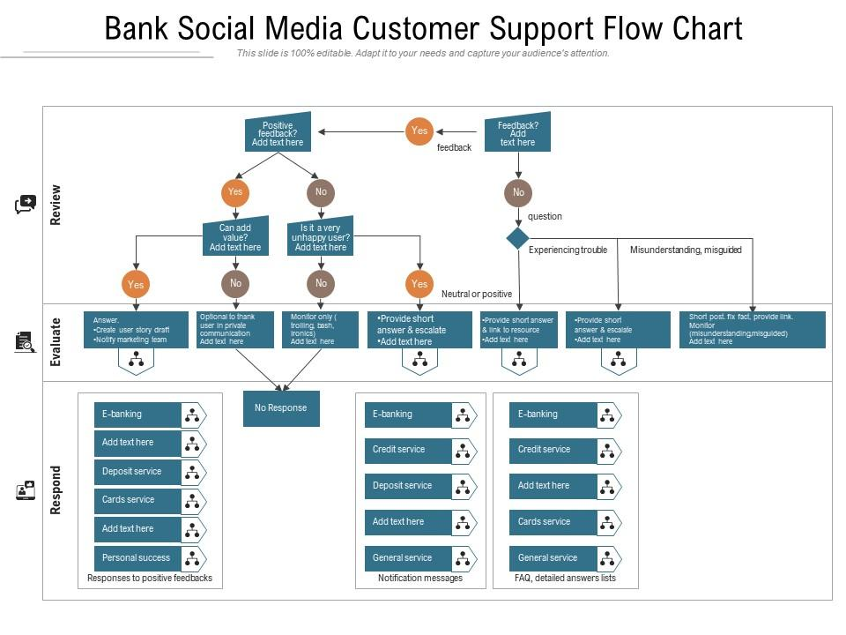

**Code:**

#include <stdio.h>

#include <stdlib.h>

#include <pthread.h>

#include <semaphore.h>

#include <unistd.h>

// Define maximum number of tasks

#define MAX_TASKS 3

// Structure to represent a task

typedef struct {

int task_id;

int period;

int execution_time;

int remaining_time;

sem_t semaphore;

} Task;

// Array of tasks

Task tasks[MAX_TASKS];

// Function prototypes

void* task_function(void* arg);

void schedule_tasks();

// Main function

int main() {

// Initialize tasks

tasks[0] = (Task){ .task_id = 0, .period = 3, .execution_time = 1, .remaining_time = 1 };

tasks[1] = (Task){ .task_id = 1, .period = 5, .execution_time = 2, .remaining_time = 2 };

tasks[2] = (Task){ .task_id = 2, .period = 7, .execution_time = 1, .remaining_time = 1 };

// Initialize semaphores for each task

for (int i = 0; i < MAX_TASKS; i++) {

sem_init(&tasks[i].semaphore, 0, 1);

}

// Create threads for each task

pthread_t threads[MAX_TASKS];

for (int i = 0; i < MAX_TASKS; i++) {

pthread_create(&threads[i], NULL, task_function, (void*)&tasks[i]);

}

// Schedule tasks

schedule_tasks();

// Join threads

for (int i = 0; i < MAX_TASKS; i++) {

pthread_join(threads[i], NULL);

}

// Destroy semaphores

for (int i = 0; i < MAX_TASKS; i++) {

sem_destroy(&tasks[i].semaphore);

}

return 0;

}

// Task function

void* task_function(void* arg) {

Task* task = (Task*)arg;

while (1) {

sem_wait(&task->semaphore); // Wait for the task to be scheduled

if (task->remaining_time > 0) {

printf("Task %d is running\n", task->task_id);

sleep(task->execution_time); // Simulate task execution

task->remaining_time = 0; // Task completed

printf("Task %d completed\n", task->task_id);

}

}

return NULL;

}

// Simple round-robin scheduler

void schedule_tasks() {

while (1) {

for (int i = 0; i < MAX_TASKS; i++) {

if (tasks[i].remaining_time > 0) {

sem_post(&tasks[i].semaphore); // Schedule the task

sleep(tasks[i].period); // Wait for the task's period

} else {

tasks[i].remaining_time = tasks[i].execution_time; // Reset remaining time

}

}

}

}

**Output**

Task 0 is running

Task 0 completed

Task 1 is running

Task 1 completed

Task 2 is running

Task 2 completed

Task 0 is running

Task 0 completed

Task 1 is running

Task 1 completed

Task 2 is running

Task 2 completed

**Conclusion**

In Conclusion we can integrate a real-time operating system (RTOS) within a multimedia communication system is pivotal for ensuring seamless, uninterrupted performance. Through the review, it becomes evident that RTOS support significantly enhances the system's ability to handle diverse multimedia data streams efficiently. By offering precise timing guarantees and prioritized task scheduling, RTOS facilitates the timely processing of multimedia data, thereby minimizing latency and ensuring optimal quality of service. Furthermore, RTOS enables effective resource management, ensuring that critical tasks receive precedence over non-essential ones, thereby maintaining system stability and reliability. Overall, the incorporation of RTOS support in multimedia communication systems emerges as a fundamental component in achieving robust real-time performance and enhancing the overall user experience.

**References:**

* Nicolaou, Cosmos. "An architecture for real-time multimedia communication systems." *IEEE Journal on selected areas in communications* 8.3 (1990).
* Fan, Changpeng. "Mmoss: Soft real-time operating system support in a multimedia communication subsystem." *IFAC Proceedings Volumes* 27.6 (1994).
* Plagemann, Thomas, et al. "Operating system support for multimedia systems." *Computer communications* (2000).
* Katcher, Daniel I., Kevin A. Kettler, and Jay K. Strosnider. "Real-time operating systems for multimedia processing." *Proceedings 5th Workshop on Hot Topics in Operating Systems (HotOS-V)*. IEEE, 1